Q1 | Create a CTE using the WITH clause to select all products with a rating above 4.5 from a 'Products' table, similar to how Flipkart or Myntra might highlight top-rated items.
Code | Create table products  CREATE TABLE Products ( product_id INT AUTO_INCREMENT, product_name VARCHAR(100), price DECIMAL(10,2), rating DECIMAL(2,1), PRIMARY KEY(product_id) );  Insert record:  INSERT INTO products(product_name,price,rating) VALUES ('iphone17promax',150000,4.5), ('AppleWatch',90000,9.5), ('DellGaminglaptop',78000,9.6), ('Dellmouse',5000,5.5), ('samsung galaxy s23 ultra',200000,9.9);  Main query  WITH product AS ( SELECT * FROM Products WHERE rating > 4.5 ) SELECT * FROM product;
Output | 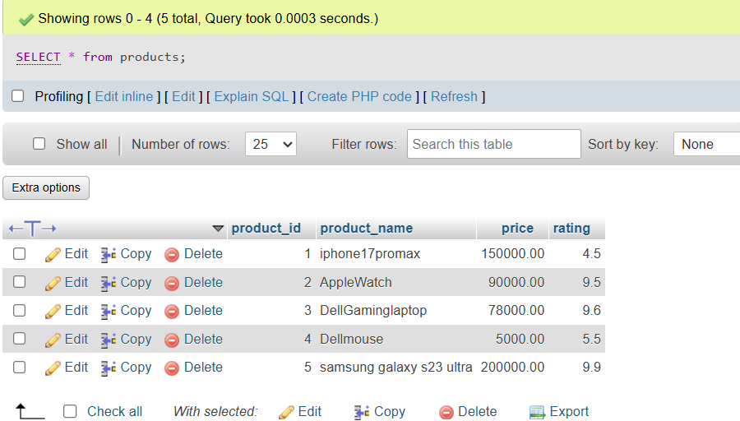  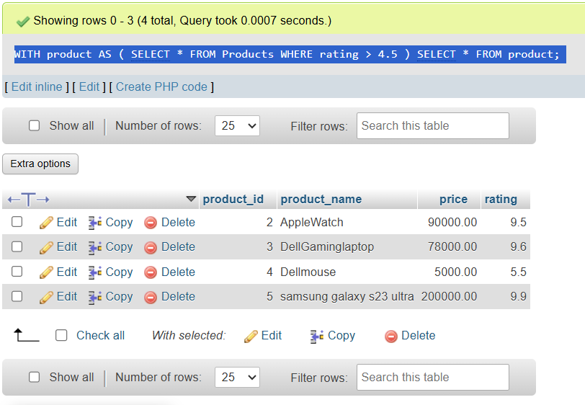

Q2 | Rewrite a query that finds all restaurants in 'Ahmedabad' with delivery charges under 50 from a 'Restaurants' table, first using a subquery and then using a CTE. Compare both queries for readability.<br><br><em><strong>Hint:</strong> Focus on making the CTE version cleaner and easier to understand.</em>
Code | Create table restaurants:  create table resturantrs( id int AUTO_INCREMENT, name varchar(100), city varchar(100), delivery_charges decimal(5,2), PRIMARY KEY(id) );  Insert record:  INSERT INTO resturantrs(name,city,delivery_charges) VALUES ('Mayank','Ahmedabad',100), ('Keval','Daman',50), ('Naitik','Rajkot',20), ('Daxay','Ahmedabad',60), ('Yash','jamnagar',200), ('Shubham','Ahmedabad',50), ('Mahek','Ahmedabad',45), ('Dipti','varodara',90), ('Yatra','mehshana',80), ('priyanshu','mehshana',55), ('Kirtan','Ahmedabad',20);  Show table:  SELECT * from resturantrs;  Main query(using subquery)  SELECT * FROM ( SELECT * FROM resturantrs WHERE city = 'Ahmedabad' ) AS R WHERE delivery_charges < 50;  Main query(using CTE)  WITH AhmedabadRestaurants AS ( SELECT * FROM resturantrs WHERE city = 'Ahmedabad' ) SELECT * FROM AhmedabadRestaurants WHERE delivery_charges < 50;
Output | 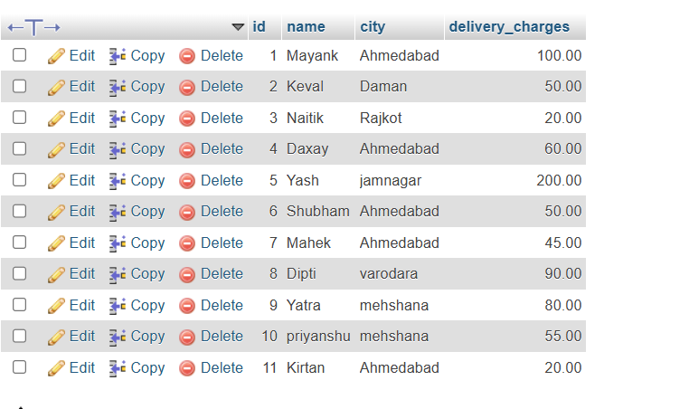  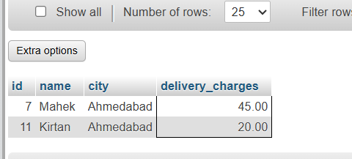  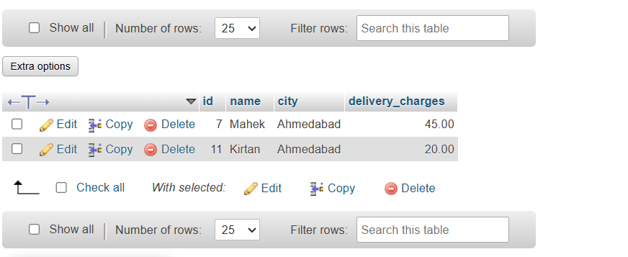

Q3 | Using two CTEs in a single query, find the top 3 most-followed users and the top 3 most-liked posts from a 'Users' and 'Posts' table (think Instagram-style data). Output both lists in the same result set.
Code | Create table users:  CREATE TABLE Users ( user_id INT AUTO_INCREMENT, username VARCHAR(50), followers INT, PRIMARY KEY(user_id) );  Insert record:  INSERT INTO users(username,followers) VALUES ('Mayank',1500), ('Yash',1800), ('Keval',1600), ('Mehul',2500), ('Rathod',2500), ('Diuu',4500), ('Dipti',9600);  Show table:  SELECT * from users;  Create second table:  CREATE TABLE Posts ( post_id INT AUTO_INCREMENT, user_id INT, title VARCHAR(100), likes INT, FOREIGN KEY (post_id) REFERENCES Users(user_id) );  Insert record:  insert INTO posts(user_id,title,likes) VALUES (2,'travel vlog',89000), (1,'Food reels',25000), (2,'Nature photography',230000), (3,'Cooking receips',45000), (3,'Gaming highlights',58000), (1,'Study Motivation',56000), (1,'Music Cover',99000);  Show table:  SELECT * FROM posts;  MAin query  WITH TopUsers AS ( SELECT username AS Name, followers AS Value, 'Top User' AS Type FROM Users ORDER BY followers DESC LIMIT 3 ), TopPosts AS ( SELECT title AS Name, likes AS Value, 'Top Post' AS Type FROM Posts ORDER BY likes DESC LIMIT 3 ) SELECT * FROM TopUsers UNION ALL SELECT * FROM TopPosts;
Output | 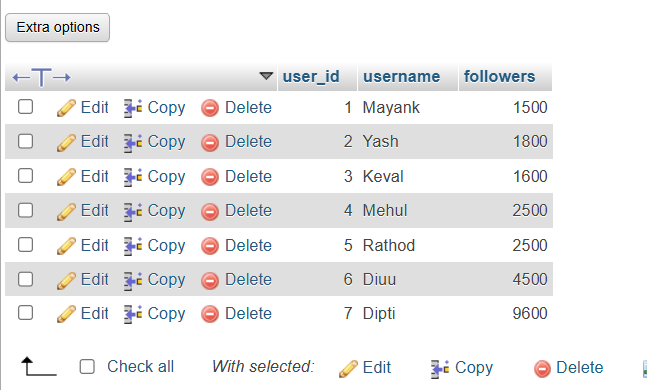  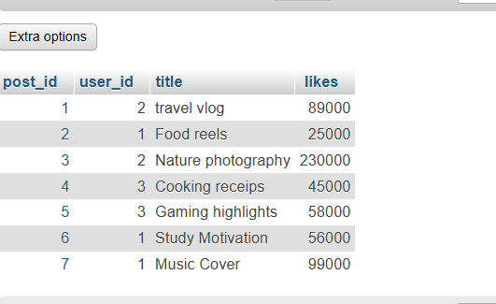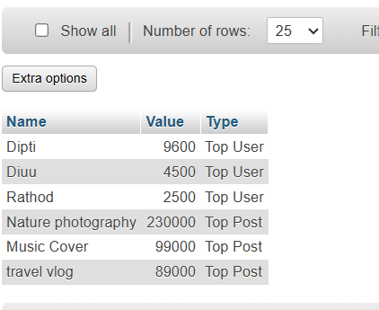

Q4 | Write a recursive CTE that generates a list of dates for the next 7 days starting from today, similar to how BookMyShow shows available dates for movie bookings.<br><br><em><strong>Hint:</strong> Use a base case for today and recursion to add one day at a time.</em>
Code | WITH RECURSIVE Next7Days AS ( SELECT CURDATE() AS booking_date UNION ALL SELECT booking_date + INTERVAL 1 DAY FROM Next7Days WHERE booking_date < CURDATE() + INTERVAL 6 DAY ) SELECT * FROM Next7Days;
Output | 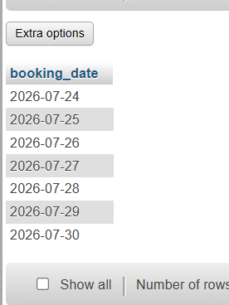

Q5 | Given a messy SQL query that finds all users with more than 1000 followers from a 'Users' table, refactor it to use a CTE for better clarity and maintainability.
Code | Create table users:  CREATE TABLE Users ( user_id INT AUTO_INCREMENT, username VARCHAR(50), followers INT, PRIMARY KEY(user_id) );  Insert record:  INSERT INTO users(username,followers) VALUES ('Mayank',1500), ('Yash',1800), ('Keval',1600), ('Mehul',2500), ('Rathod',2500), ('Diuu',4500), ('Dipti',9600);  Show table:  SELECT * from users;  Original (Messy) Query  SELECT * FROM ( SELECT * FROM Users WHERE followers > 1000 ) AS PopularUsers;  Refactored Query Using a CTE  WITH PopularUsers AS ( SELECT * FROM Users WHERE followers > 1000 ) SELECT * FROM PopularUsers;
Output |   